Extending Drives

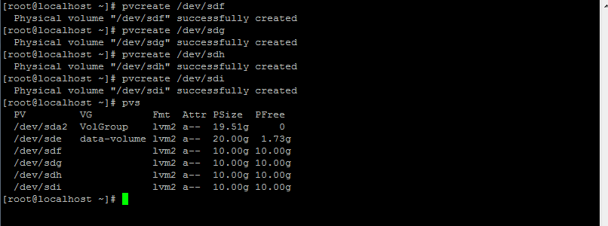

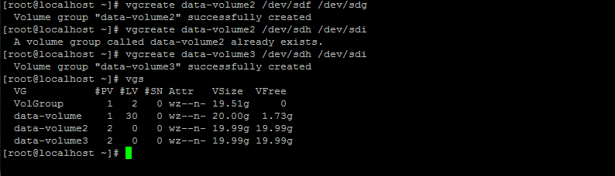

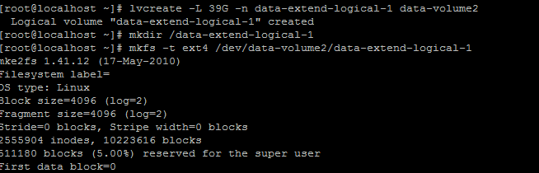

C:\Users\Ulhas\Desktop\LinuxScreenshots\Combine 2 Drives\part-4checking.PNG

C:\Users\Ulhas\Desktop\LinuxScreenshots\Combine 2 Drives\part-4mount.PNG

